**Copperfield Neighborhood Association Board of Directors Meeting**

**Monthly Meeting Minutes**

**Monday, July 10, 2017**

**Call to Order**

The Copperfield Neighborhood Association Board of Directors Meeting was held at 1336 Copper Run Boulevard, Lexington, Kentucky on Monday, July 10, 2017. The meeting convened at 7:00pm.

**Persons In Attendance**

Treasurer Josh Greeman, Secretary Jennifer Roe, At Large Warren Anderson, At Large Karen Whitmer, President CA Post.

**Others In Attendance**

Resident: Matthew Burch

**Approval of Minutes**

The approval of the June Monthly Meeting Minutes was conducted via email on July 12.

**Business**

**Commercial Vehicle Policy:** We are going to shelve this issue for now. There seem to be too many possibilities and hindrances, such as who is going to monitor the violations, send out notices, and how do we even prove a violation? The Board’s sense is that the DOR on this is aimed at persistent and egregious violators.

**Notice to Delinquent Payers**: CA is going to contact each of the delinquents and let them know that we are going to publish their names in an email. Josh states they have also already received letters in the mail. CA is still going to USPS deliver notices to let them know. He will mail these on the 14th so that an email can be sent to the CNA on August 1.

**Copper Run Boulevard Speeding:** Petition will ask for a three way stop sign at Copper Run Boulevard and Copperfield Drive, and a reduction in speed limit from 35 to 25 mph. We will mail the petitions out to the homeowners. We are also going to ask for additional "Children At Play" signs.

**Spectrum Progress**: We need to get installation set up. The proposed bid from Spectrum will save the CNA about $130 per month for cable, telephone, and internet services. Contract is for one year, and we will probably have to renegotiate in a year.

**1325 Corona Drive**: Ben claims he has paid and sent us an email with list of payments hand-written on the bottom of the page (not copies of checks). He had been sending in checks for his aged dues, but they have been sent from his father's company with no indication of address nor purpose of the check. They were also made out in amounts of what it would cost for Clubhouse rentals, so his payments were being applied as Clubhouse rental on our end. Josh was able to verify that Mr. Levy’s Annual Dues are paid up through 2017. Liens will be released when C.A. has opportunity to draw up the releases and go to the County Clerk’s Office.

**Special Assessment Collections:** 90 out of 433 required have paid (21% or $37,950/$173,200) as of June 30. CA is going to send another email notification reminder about the Assessment.

**Signature Authority:** Only three signers on the bank account as of now. We are going to leave it that way for now.

**Savings Account:** Josh set up a separate savings account for the Special Assessment collections.

**Financials:** Mortgage is variable rate and is going up .25% in July, so it is to our advantage that we are going to pay off the full mortgage this year.

**1448 Corona Drive:** This house was turned over to a bank with the departure of the previous residents. The bank and involved agencies have made full payments of Annual dues. This lien will also be removed.

**Mailbox for 1336 Copper Run Blvd:** We decided on a mailbox to install in the existing brick work mailbox, but it is one which provides security from theft. C.A. will order it from Lowes.

**Attachments to Minutes:**

**1 Delinquent Dues Payers as of this date**

**2 Financials for CNA**

**3 Email update from Tim Geertz on Facilities.**

**Adjournment**

The next monthly meeting will be Monday, August 14, 2017, at 7:00pm at the Clubhouse. The July 10, 2017 meeting was adjourned at 8:03pm.

***Jennifer Roe***

***Secretary***

**1 Delinquent Annual Dues Payers 2017 (unpaid as of July 10, 2017):**

|  |  |  |  |  |  |  |  |  |  |  |  |  |
| --- | --- | --- | --- | --- | --- | --- | --- | --- | --- | --- | --- | --- |
| |  |  | | --- | --- | | JANET FLINN | 1300 COPPER RUN BLVD | | BRYAN JONES & HONG HUANG | 1360 GLENVIEW DR | | RODNEY & KATHY FAIN | 1381 COPPER CREEK DRIVE | | EDGAR BAKER | 1401 COPPER RUN BLVD (deceased) | | MARK YATES | 1408 CORONA DR | | LLOY SCHOLL | 1457 COPPER GLEN DR | |

**2 Financials for CNA:**

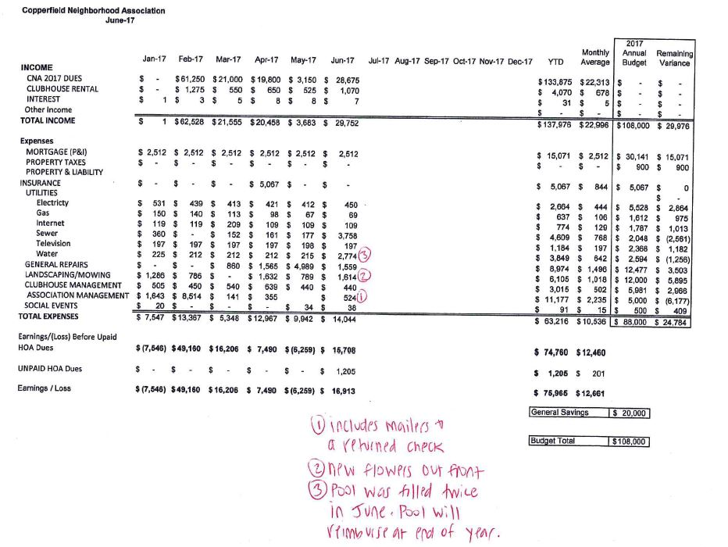

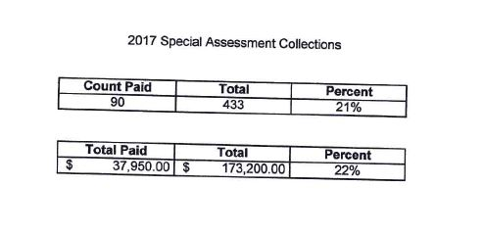

**3 Email Update on Facilities from Tim Geertz:**

